Software Requirements
Specification
for

Campus Management Application
at
World Skill Center (WSC)

Business Feature - Students Management Module



Sustainable Outreach And Universal Leadership (SOUL) Limited
Version no 0.3

VERSION HISTORY
Date | Version No. | Created By | Updated Section | Updated By
18-01-2022 | Version 0.1 | Nehal Kumar
19-01-2023 | Version 0.2 | Nehal kumar, | Added Field Type, UI | Nehal kumar, Priytesh Shah
20-01-2023 | Version 0.3 |  | Sections updated 1.1, 1.2, 1.3, Section 2 - sub sections (UI & Field type tables) Section 4  Added sections 1.4, 1.5, Section 5 | Sharmistha Panda

Table Of Contents

1. Introduction 3
1.1 Document Overview 3
1.2 Scope 3
1.3 Definitions, Acronyms, and Abbreviations 4
1.4 Intended Users 4
1.5 User Access and Privileges 4
2. Master Screen 4
2.1 Department 4
2.2 Program grade 5
2.3 Programs 5
2.4 Semesters 7
2.5 Courses 8
2.6 Class room 9
2.7 Academic year 9
2.8 Academic term 10
3. Business Module 10
3.1 Students Managements Modules & Academic System 10
3.1.1 Admission 11
3.1.2 Academics 11
3.1.3 Examinations 11
3.1.4 Hostel 11
4. Integration 12
4.1 Email Integration 12
4.2 Payment Process 12

Table of Figures

Figure 1 5
Figure 2 5
Figure 3 6
Figure 4 7
Figure 5 8
Figure 6 9
Figure 7 10
Figure 8 11

Introduction

Document Overview

This document presents the software requirements specifications of Campus Management Application software development project.

It describes the following :
Business Features
Functionality of the features
User Interface
Field Types

Scope

The scope of this document are the features of Students Management Modules such as Admission, Academics, Examination and Hostel

Definitions, Acronyms, and Abbreviations

Abbreviations will be added here

Intended Users

The system shall be available to and accessible by Admission Administrator, Academics Administrator, Examination Administrator and Hostel Administrator

User Access and Privileges

Admission Administrator shall be able to access the functionalities mentioned in Section 2

Master Screen

Master screens are the core screens / data that is absolutely essential for running operations within a business enterprise or unit

Department

A Department is a specialized functional area or a division within an organization.Department is a tree-structured master, which means you can create parent departments and sub-departments.

- User Interface

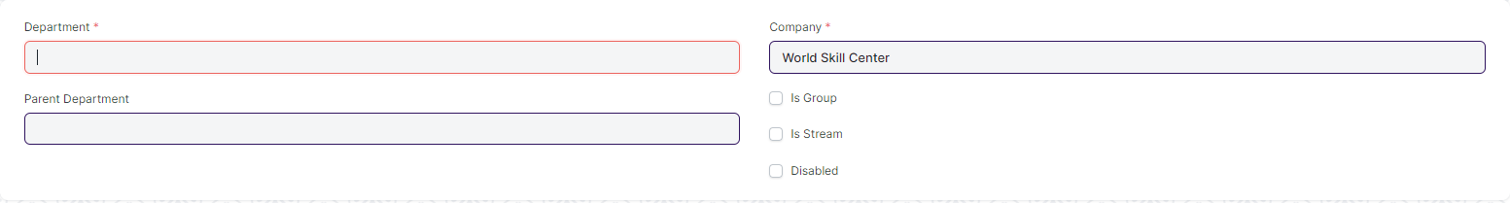
UI Wireframe
Figure 1

- Field Type
Field Label | Type | Options | Mandatory
Department | Data |  | Yes
Parent Department | Link | Department | No
 | Column Break |  | No
Company | Link | Company | Yes
Is Group | Check |  | No
Disabled | Check |  | No

Program grade

In Program grade we define grade,degree, terms which are use for Academics like PG, UG etc

- User Interface

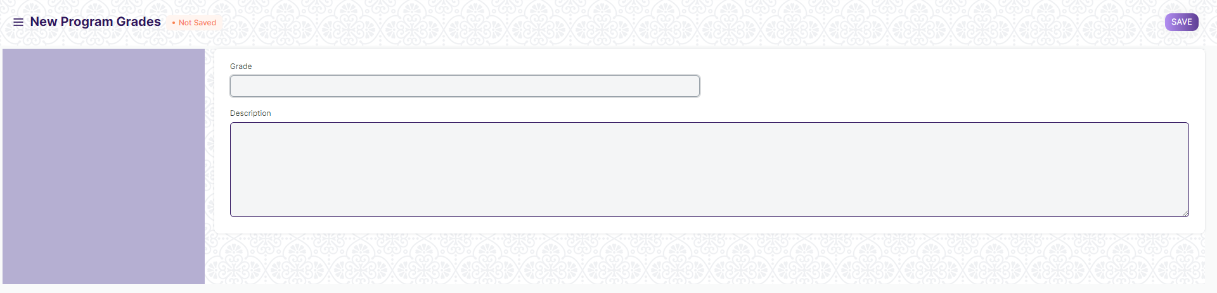
UI Wireframe
Figure 2
- Field Type

Field Label | Type | Options | Mandatory
Grade | Data
Description | Small Text

Programs
A Program will have an educational curriculum defined by your institute to streamline the learning process and goals in each subject or course.

- User Interface

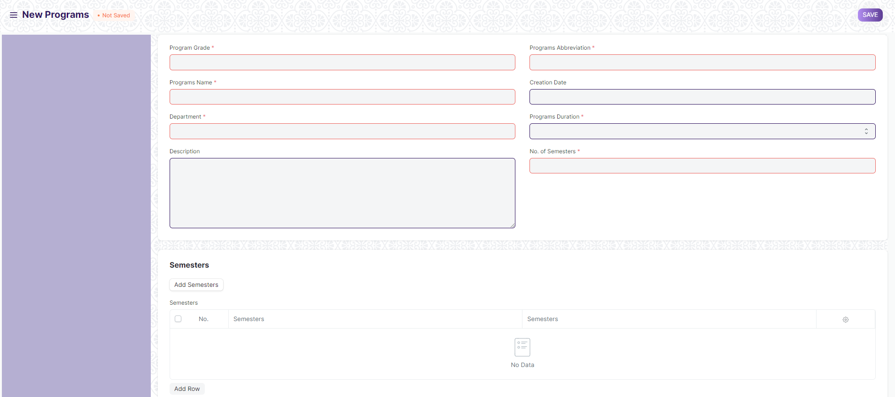
UI Wireframe
Figure 3
- Field Type:

Field Label | Type | Options | Mandatory
Program Grade | Link | Program Grades | Yes
Programs Name | Data |  | Yes
Department | Link | Department | No
Description | Small Text |  | No
 | Column Break |  | No
Programs Abbreviation | Data |  | Yes
Creation Date | Date |  | No
Programs Duration | Select | 1 Year  2 Years  3 Years  4 Years  5 Years  6 Years  7 Years  8 Years  9 Years  10 Years | Yes
No. of Semesters | Int |  | Yes
Semesters | Section Break |  | No
Add Semesters | Button |  | No
Semesters | Table | Semesters | No
Portal Settings | Section Break |  | No
Is Published | Check |  | No
Allow Self Enroll | Check |  | No
Is Featured | Check |  | No
 | Column Break |  | No
Intro Video | Data |  | No
Hero Image | Attach Image |  | No
Description | Small Text |  | No

Semesters

It is used to keep track of academic progress in a systematic way, by tracking attendance, test scores, grades and other important metrics.

- User Interface:

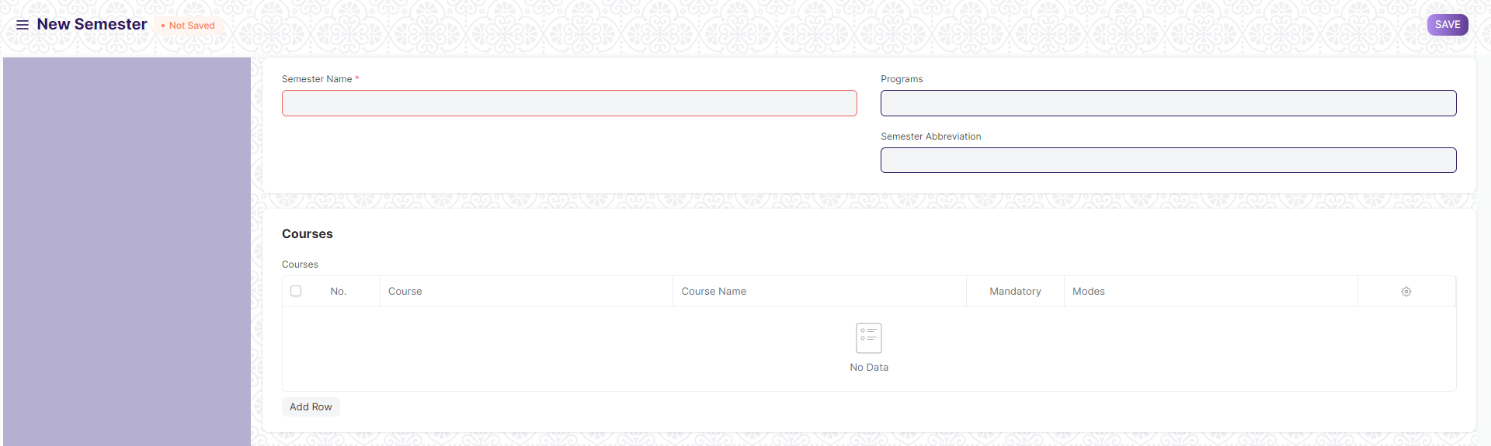
UI Wire frame
Figure 4

- Field Type:

Field Label | Type | Options | Mandatory
Program Name | Data |  | Yes
Department | Link | Department | No
 | Column Break |  | No
Program Abbreviation | Data |  | No
Courses | Section Break |  | No
Courses | Table | Program Course | No
Portal Settings | Section Break |  | No
Is Published | Check |  | No
Allow Self Enroll | Check |  | No
Is Featured | Check |  | No
 | Column Break |  | No
Intro Video | Data |  | No
Hero Image | Attach Image |  | No
Description | Small Text |  | No

Courses

A course can be considered as a subject or a part of an educational program which is to be taught for a term.

- User Interface:

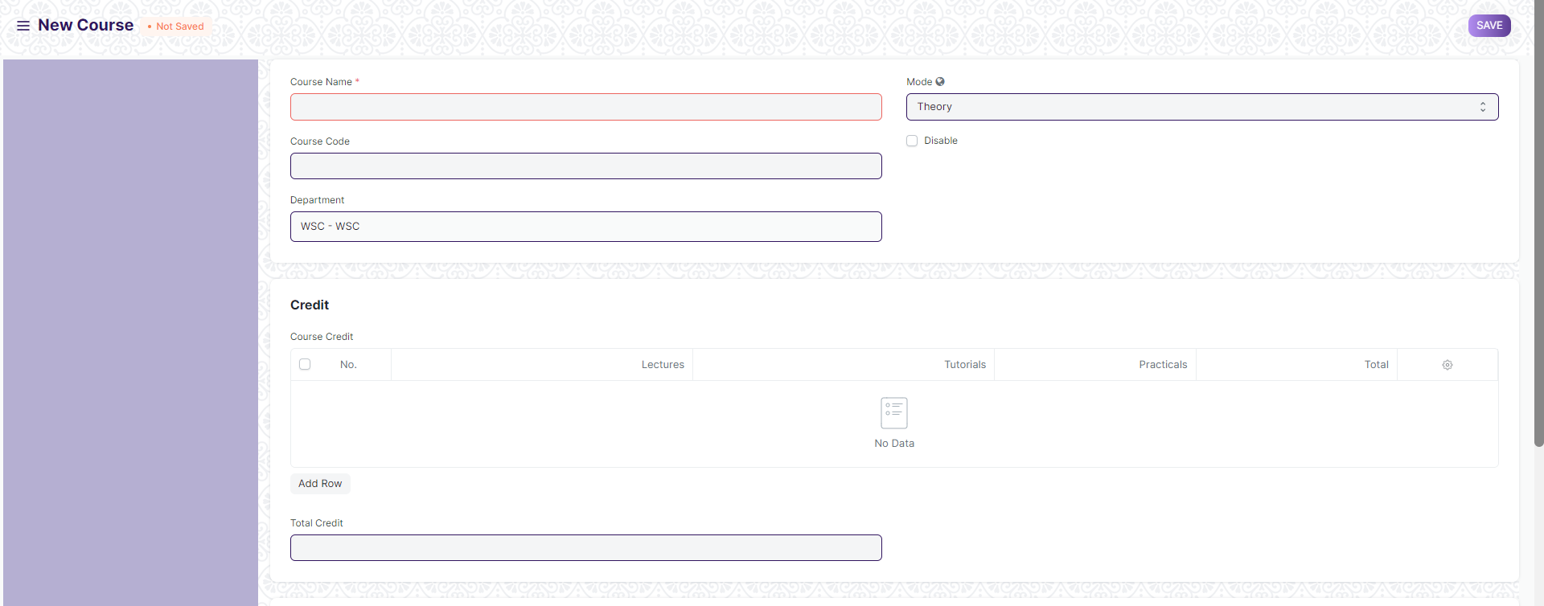
UI Wire frame
Figure 5

- Field Type:

Field Label | Type | Options | Mandatory
Course Name | Data |  | Yes
Department | Link | Department | No
Portal Settings | Section Break |  | No
Topics | Table | Course Topic | No
Description | Small Text |  | No
Hero Image | Attach Image |  | No
Assessment | Section Break |  | No
Default Grading Scale | Link | Grading Scale | No
Assessment Criteria | Table | Course Assessment Criteria | No

Class room

Room refers to a tutoring space which can be set as the venue for courses or examinations.

- User Interface:

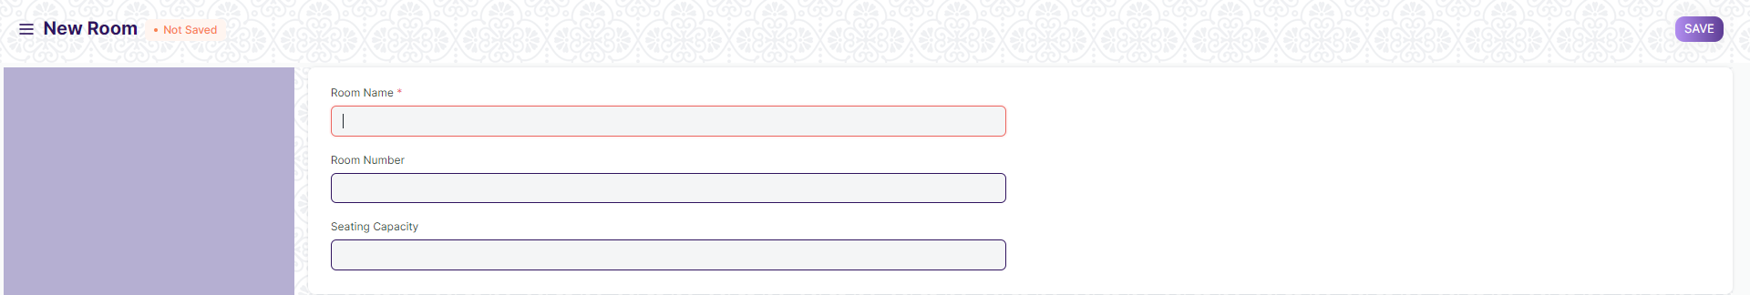
UI Wire frame
Figure 6

- Field Type:

Field Label | Type | Options | Mandatory
Room Name | Data |  | Yes
Room Number | Data |  | No
Seating Capacity | Data |  | No

Academic year

An academic year is a period which the Educational Institutes, Schools and Universities use to measure a quantity of study.
- User Interface:

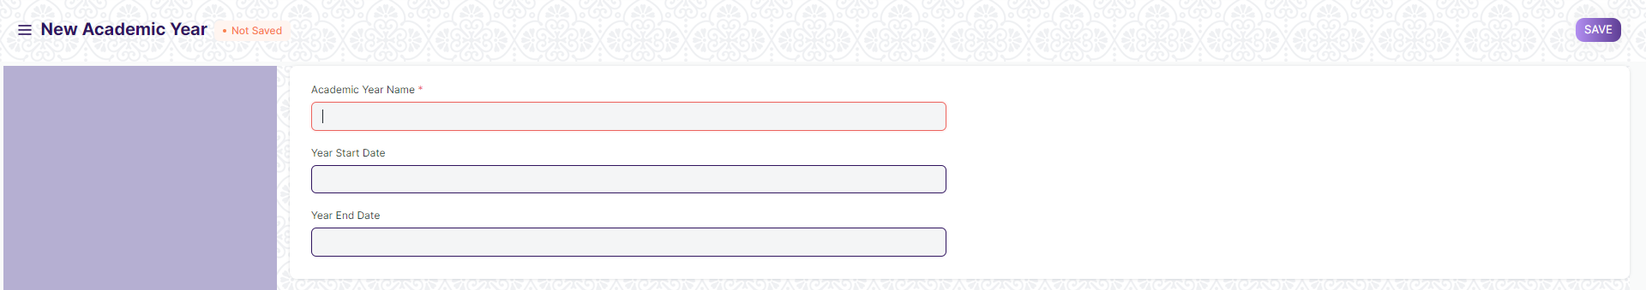
UI Wire frame
Figure 7

- Field Type:
Field Label | Type | Options | Mandatory
Academic Year Name | Data |  | Yes
Year Start Date | Date |  | No
Year End Date | Date |  | No

Academic term
An Academic Term would become a part of the Academic Year, during which the Institute will assess its Students on the curriculum defined for that term. It could be a Quarter, Trimester or a Semester.

- User Interface:

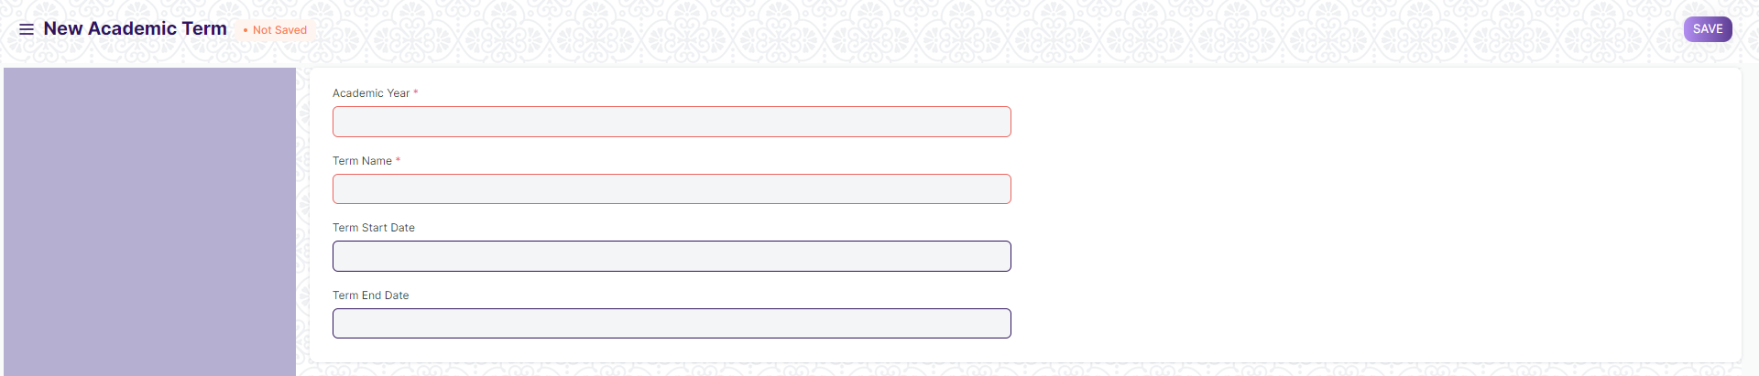
UI Wire frame
Figure 8

- Field Type:
Field Label | Type | Options | Mandatory
Academic Year | Link | Academic Year | Yes
Term Name | Data |  | Yes
Term Start Date | Date |  | Yes
Term End Date | Date |  | Yes
Title | Data |  | No

Business Module

Students Managements Modules & Academic System
The Students Management Modules & Academic Systems are a comprehensive set of tools designed to help schools and universities manage their students and their academic progress. The various modules included in the system are :
- Admission
- Academics
- Examinations
- Hostel

Admission
The Admission module allows schools/colleges to easily manage the enrollment process, ensuring that all necessary paperwork and documents are collected and tracked. With this module, schools/colleges can easily manage the information of new students, including personal data, family details, and other relevant information. It also provides the ability to generate ID cards for students.
In short, Admission module handles the entire Admission process of Students. It helps the organization to manage Admission inquiry, Admission form, Admission set up, Previous mark entry, Student sorting based on merit and Admission confirmation etc.

Academics
The Academics module allows schools to manage their student’s academic progress. With this module, schools can easily track grades, attendance records, and other academic related information. It also provides the ability to generate course schedules and reports for each student.
Academics module handles the entire process of Student record in his educational career. It helps the organizations to manage Attendances, Student Leaves, Placement & Drives, Mentor & student groups allocation and related reports etc.

Examinations
The Examinations module allows schools to manage their student’s examination and assessment process. This module provides the ability to create and manage exams, provide feedback to students, and generate reports. Examinations modules handles the entire process of Student Academics Exam process like it’s helps to manage Exam declaration, Exam Application, Paper setting, Admit card, Evaluation, Result declaration, Certificate and related reports etc.

Hostel
The Hostel module allows schools to manage their student’s accommodation. With this module, schools can easily track the availability of rooms, assign accommodations to students, and manage payments. It also provides the ability to generate reports related to student accommodation.
In short, Hostel modules is designed to manage all hostel activities like hostel admissions, fees, room and generates related reports for smooth transactions. It is also used to manage all fees bill calculation and etc.

Integration

Content with respect to application integration

Email Integration

The following content shall be added :
Scenarios when the email shall be triggered
Email recipient
Email template

Payment Process
About payment…..

System Settings

Content to be added in case any settings with respect to this module to be done

